School Psychologists

Jeremy Husfeldt,
Nationally Certified School Psychologist (NCSP)
Alexandria Public Schools
Discovery Middle School
Garfield Elementary
Carlos Elementary
Miltona Elementary
Zion / New Testament / St. Mary’s

Kristen Steen, PsyS
Nationally Certified School Psychologist (NCSP)
Alexandria Public Schools
Lincoln Elementary
Woodland Elementary
Early Childhood

Angie Scott, PhD
Nationally Certified School Psychologist (NCSP)
Parkers Prairie Public School
Minnewaska Area School District

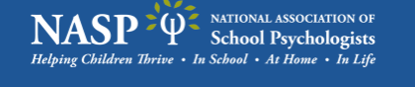
https://www.nasponline.org/

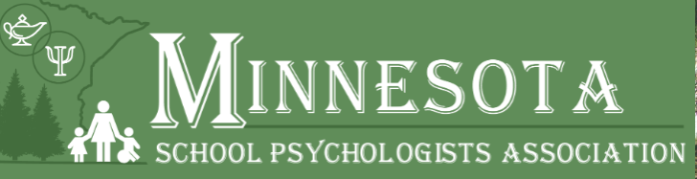
https://www.mspaonline.net/

Special Education Categorical Disabilities
https://education.mn.gov/mde/dse/sped/cat/

https://www.understood.org/

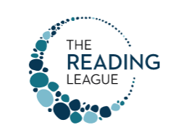
https://www.thereadingleague.org/

Supporting Twice Exceptional Students
https://www.nagc.org/supporting-twice-exceptional-students

https://ausm.org/

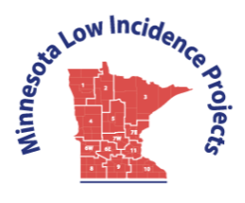
http://www.mnlowincidenceprojects.org/index.html

https://www.ldaminnesota.org/

